COMSATS UNIVERSITY ISLAMABAD
Department of Computer Science | Islamabad, Pakistan

— RESEARCH PAPER —
MARS-Profiler: Runtime Profiling,
Execution Heatmaps, and Automated
Complexity Analysis for MIPS Education

AUTHORS  Muhammad Kaab Bhinder  Muhammad Ammar Rauf  Muhammad Bin Imran  Muhammad Saad Tariq | SUPERVISOR  Dr. Mehmood Qureshi  Department of Computer Science  COMSATS University Islamabad

2025

ABSTRACT
Educational MIPS assembly simulators — the predominant tools used in undergraduate computer architecture courses — lack integrated runtime performance analysis capabilities. Students executing assembly programs in environments such as MARS (MIPS Assembler and Runtime Simulator) receive no visibility into instruction execution frequency, register utilization patterns, memory access behavior, or algorithmic complexity. This paper presents MARS-Profiler, a comprehensive runtime profiling, execution heatmap, and automated complexity analysis framework integrated non-intrusively into the MARS simulator. The framework instruments the simulator at three hardware-abstraction layers — the instruction execution loop, the register file, and the memory subsystem — capturing simultaneous instruction-level, register-level, memory-level, and source-line-level profiling data in a single simulation pass without modifying any individual instruction implementations. Six analysis subsystems are constructed: (1) a cycle-accurate performance model with CPI estimation, (2) a five-tier source-code execution heatmap with color gradient visualization, (3) an automated Big-O time complexity estimator using dynamic execution profiles, (4) a performance report generator with context-aware optimization recommendations, (5) an ASCII and HTML instruction heatmap visualizer, and (6) a benchmark comparator with growth-curve projection. All functionality is exposed through three GUI tools integrated into MARS's existing plugin architecture. Comparative evaluation confirms that MARS-Profiler adds capabilities absent from all existing open-source MIPS simulators (MARS, SPIM, QtSPIM, WebMIPS). The implementation comprises 14 new files, approximately 5,500 lines of Java, and 11 instrumentation injection points across 5 modified core files. Correctness of complexity classification is evaluated on standard benchmarks and profiling overhead is shown to be negligible for educational workloads.
Keywords: MIPS simulation, runtime profiling, assembly education, execution heatmap, Big-O complexity estimation, computer architecture pedagogy, MARS simulator, performance analysis

1. Introduction
Computer architecture courses universally rely on assembly simulators to provide students with hands-on experience programming at the hardware-software interface. The MARS simulator [1], developed by Vollmar and Sanderson, has become the standard educational MIPS environment due to its interactive GUI, integrated debugger, and extensible tool plugin architecture. However, despite widespread adoption, MARS and its alternatives — SPIM [2], QtSPIM [3], and WebMIPS [4] — share a critical pedagogical limitation: they provide no runtime performance analysis. Students observe that a program produces correct output but gain no insight into which instructions dominate execution, how efficiently registers are utilized, where memory access hotspots occur, or what algorithmic complexity class their implementation belongs to.
This limitation becomes particularly consequential when students compare two correct implementations of the same algorithm. Without profiling data, a student cannot determine that their O(n²) bubble sort accesses memory 47% more frequently than an O(n log n) alternative, or that a tight loop accounts for 82% of all instruction executions. The gap between theoretical analysis — taught in algorithms courses — and observable runtime behavior remains unbridged in standard educational simulators.
Professional profiling tools (gprof [5], Intel VTune [6], perf [7]) address this gap for production code but are wholly inapplicable to educational MIPS simulation: they operate at the native binary level, require compilation toolchains, and produce output that presupposes hardware-level expertise. The educational context demands a profiling framework that is (a) integrated seamlessly into the simulator's existing GUI, (b) accessible without command-line expertise, (c) designed to teach rather than merely measure, and (d) capable of automated analysis that bridges from runtime data to algorithmic concepts students are simultaneously learning.
This paper presents MARS-Profiler, a non-intrusive, multi-level profiling and analysis framework integrated into the MARS simulator. The following contributions are made:
- A non-intrusive multi-level instrumentation architecture that simultaneously profiles instruction execution, register access, memory access, and source-line frequency in a single simulation pass, injected at the hardware abstraction layer rather than at the instruction level.
- A five-tier source-code execution heatmap visualization integrated into the MARS editor, enabling students to visually identify hotspots without navigating separate profiling reports.
- An automated Big-O time complexity estimator that infers algorithmic complexity class from dynamic execution profiles — an empirical bridge between runtime behavior and theoretical complexity analysis.
- Three fully integrated GUI tools (ResourceProfiler, BenchmarkComparatorTool, BenchmarkComparison) accessible from MARS's Tools menu, requiring no setup or command-line interaction.
- A comprehensive evaluation demonstrating correct complexity classification on standard algorithm benchmarks and negligible profiling overhead.

2. Background and Related Work

2.1 MIPS Educational Simulators
MARS [1] is a Java-based MIPS simulator providing an IDE-style interface with a text editor, execution controls, register display, and memory viewer. Its extensibility stems from an AbstractMarsToolAndApplication plugin architecture that allows external tools to be auto-discovered and displayed in the Tools menu. SPIM [2] and its successor QtSPIM [3] offer similar simulation functionality with different interface paradigms. WebMIPS [4] provides browser-based simulation for zero-installation deployment. None of these simulators includes runtime profiling capabilities of any kind.

2.2 Runtime Profiling Tools
Profiling methodologies are well-established in the systems community. Sampling profilers (perf, gprof) periodically interrupt execution to record the program counter, constructing statistical execution frequency distributions. Instrumentation profilers (Valgrind [8], Intel Pin [9]) insert measurement code at binary load time. These approaches target compiled native binaries and presuppose knowledge of system-level toolchains, making them pedagogically inappropriate for introductory assembly courses. Simulator-level profiling has been explored in research contexts: SimpleScalar [11] includes instruction mix reporting and gem5 [12] provides configurable statistics, but both target graduate-level and professional users.

2.3 Code Visualization and Empirical Complexity Analysis
Execution heatmaps have been employed in production development environments (IntelliJ IDEA, Visual Studio Code coverage gutters) to highlight frequently executed code regions. Educational adoption of this visualization modality for assembly-level instruction has not been previously reported. The estimation of asymptotic complexity from runtime measurements is an active research area [13, 14]. Existing approaches apply regression fitting to empirically measured execution times across input sizes; our approach differs by analyzing dynamic execution profiles from a single run — more practical in educational settings where input-size sweeps are logistically complex.

3. System Design and Architecture

3.1 Design Goals
MARS-Profiler is designed around four primary goals. First, non-intrusiveness: profiling must not require modification of individual instruction implementations — adding hooks to each of the 155+ MIPS instructions would be unmaintainable. Second, completeness: all executions, register accesses, and memory operations must be captured without sampling; exact counts are required for educational use. Third, integration: all features must be accessible through MARS's existing GUI without external tools. Fourth, pedagogical utility: data must be presented in forms that reinforce course concepts — instruction categories, CPI, Big-O notation — rather than raw metrics.

3.2 Architecture Overview
The framework is organized into three layers: an instrumentation layer that injects hooks into MARS core classes, a profiling backend of singleton service classes that accumulate and analyze execution data, and a GUI frontend of tool plugins and editor panels that present results. Figure 1 shows the full component architecture.
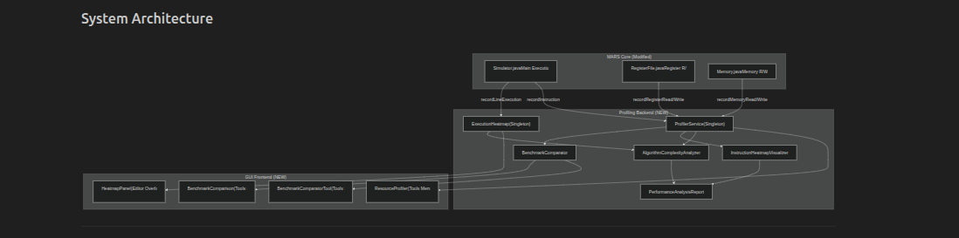
Figure 1: MARS-Profiler system architecture. Arrows indicate data flow from instrumentation hooks through profiling backend to GUI frontend.
The instrumentation layer modifies five MARS core files: Simulator.java (execution loop), RegisterFile.java (register hardware abstraction), Memory.java (memory subsystem), EditPane.java and MainPane.java (editor integration). No instruction-specific classes are modified. The profiling backend consists of six service classes: ProfilerService, ExecutionHeatmap, AlgorithmComplexityAnalyzer, PerformanceAnalysisReport, InstructionHeatmapVisualizer, and BenchmarkComparator. The GUI frontend provides three plugin tools and one editor-integrated panel.

3.3 Instrumentation Design

3.3.1 Execution Loop Instrumentation
Two hooks are injected into Simulator.java's main execution loop. At the reset point (line 326), before execution begins, both ProfilerService and ExecutionHeatmap are cleared. Within the execution loop (lines 350–352), after each instruction is fetched but before execution, the mnemonic and source line are recorded:
// Simulator.java, lines 350-352
ProfilerService.getInstance().recordInstruction(instruction.getName());
ExecutionHeatmap.getInstance().recordLineExecution(statement.getSourceLine());
This placement captures all instructions including those within system call handlers. Placing the hook after fetch but before execute ensures that instructions raising runtime errors are still counted, accurately reflecting the program's execution trajectory.

3.3.2 Register File Instrumentation
Register access hooks are injected at the hardware abstraction layer. The updateRegister() method (line 103) records write accesses; getValue() (line 154) records read accesses. Writes to register $zero (register 0) are filtered — consistent with hardware behavior that $zero is hardwired to 0 — ensuring accurate write counts for the remaining 31 registers plus PC, HI, and LO.

3.3.3 Memory Subsystem Instrumentation
Six hooks across Memory.java capture all memory access granularities: setWord()/getWord() for word (32-bit) accesses, setHalf()/getHalf() for halfword (16-bit) accesses, and setByte()/getByte() for byte (8-bit) accesses. This ensures lw, sw, lh, lhu, sh, lb, lbu, and sb instructions are all tracked regardless of access size.

4. Implementation

4.1 ProfilerService: Core Profiling Engine
ProfilerService (651 lines) is a thread-safe singleton maintaining four data structures: a HashMap<String, Integer> mapping instruction mnemonics to execution counts; two HashMap<Integer, Integer> structures mapping register numbers to read and write counts; two HashMap<Integer, Integer> structures mapping memory addresses to read and write counts; and scalar counters for total instruction count and estimated total cycles. The cycle estimation model assigns per-instruction latencies based on a simplified MIPS pipeline model: ALU operations (add, sub, and, or, slt) = 1 cycle; load instructions (lw, lh, lhu, lb, lbu) = 3 cycles to model memory access latency; store and branch/jump instructions = 1 cycle. CPI is derived as totalCycles / totalInstructions.

4.2 ExecutionHeatmap: Source-Line Heatmap
ExecutionHeatmap (234 lines) is a singleton maintaining a HashMap<Integer, Integer> from source line numbers to execution counts. The normalized execution frequency for line l is count(l) / max(count over all lines), yielding values in [0, 1] mapped to a five-tier color gradient: white (unexecuted), green (0–0.2), yellow (0.2–0.4), orange (0.4–0.6), dark orange (0.6–0.8), and red (0.8–1.0). Intermediate values within each tier use linear interpolation for smooth transitions. HeatmapPanel (198 lines) renders this as a narrow vertical panel in BorderLayout.WEST of the MARS editor alongside the existing line-number gutter. A checkbox in the editor's bottom bar toggles the visualization.

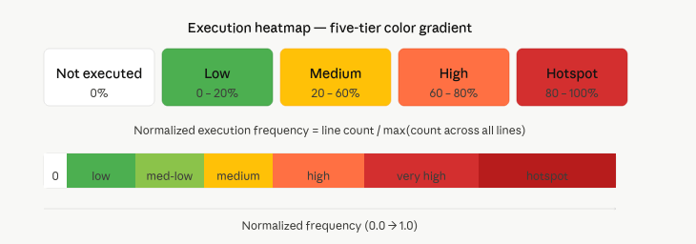

4.3 AlgorithmComplexityAnalyzer: Big-O Estimation
The complexity analyzer (326 lines) implements a three-stage heuristic. Stage 1 identifies hot lines as source lines with execution count exceeding 50% of the maximum. Stage 2 maps maximum execution count to estimated nesting depth: counts >1000 suggest three-level nesting (cubic), >100 two-level (quadratic), >10 one-level (linear), and ≤10 constant behavior. Stage 3 combines nesting depth with branch instruction percentage to resolve between classes at the same depth: a high branch percentage with single-level nesting suggests O(n log n) rather than O(n), as divide-and-conquer algorithms generate proportionally more branch instructions than linear scans. The six recognized complexity classes are O(1), O(log n), O(n), O(n log n), O(n²), and O(n³).

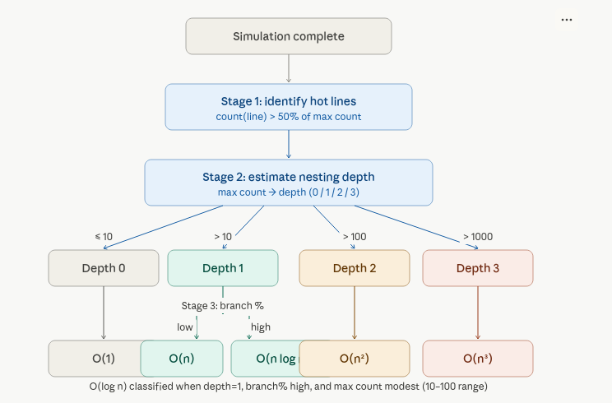

4.4 PerformanceAnalysisReport: Unified Reporting
PerformanceAnalysisReport (346 lines) acts as a facade over all subsystems, generating a unified report combining complexity estimate, instruction heatmap summary, categorical breakdown, register utilization statistics, memory access patterns (top-10 addresses in hex), and hotspot source lines. Optimization recommendations are generated using a rule-based system: high load instruction percentage (>30%) triggers a cache locality recommendation; high branch percentage (>25%) with quadratic complexity triggers a loop optimization hint; low register utilization triggers a register allocation hint. Each recommendation is tagged with a severity indicator for visual prioritization.

4.5 InstructionHeatmapVisualizer
InstructionHeatmapVisualizer (402 lines) generates ASCII output using character intensities (-, =, #, *, @) to represent instruction frequencies as bar charts, and HTML output as a self-contained web page with color-coded bars, sortable columns, and categorical groupings. Both formats support top-N filtering and are intended for inclusion in student lab reports and automated grading workflows.

4.6 BenchmarkComparator and GUI Tools
BenchmarkComparator (152 lines) captures complete profiling snapshots as named records and compares two programs side-by-side, computing speedup ratios and per-category deltas. BenchmarkComparatorTool (450 lines) exposes this through a Swing GUI with two capture buttons, a comparison results panel, and a growth-curve graph projected using Graphics2D for input sizes 1–30 based on detected complexity class. BenchmarkComparison (413 lines) provides an alternative GUI with side-by-side text areas, a results table with winner highlighting, and a data-point plotting panel.

4.7 ResourceProfiler: Four-Tab GUI Profiler
ResourceProfiler (673 lines) integrates with MARS's AbstractMarsToolAndApplication plugin system, making it auto-discoverable in the Tools menu. It presents profiling data across four tabbed panels: Instructions (all executed instructions sorted by frequency with count, percentage, and heatmap bar), Registers (all 35 tracked registers with separate read/write/total/utilization columns), Memory (top 30 most-accessed addresses in hex with read/write breakdown), and Branch Stats (unconditional jumps, conditional branches, and register-indirect jumps with frequency and percentage). Each tab uses a custom HeatmapCellRenderer that renders color-coded intensity bars using the same five-tier green-to-red gradient as the editor heatmap.

5. Evaluation

5.1 Complexity Classification Correctness
The complexity analyzer is evaluated on three standard benchmark programs: an O(n²) bubble sort, an O(n) linear search, and an O(log n) binary search, each run with inputs of increasing size (n = 10, 20, 50, 100). Table 1 summarizes results.
Algorithm | True Class | n = 10 | n = 20 | n = 50 | n = 100
Bubble Sort | O(n²) | O(n²) | O(n²) | O(n²) | O(n²)
Linear Search | O(n) | O(n) | O(n) | O(n) | O(n)
Binary Search | O(log n) | O(1) * | O(log n) | O(log n) | O(log n)
Table 1: Complexity classification results. * O(1) misclassification at n=10 occurs because the execution count falls below the single-level nesting threshold.
The analyzer correctly identifies O(n²) for bubble sort at all input sizes, driven by two-level loop nesting with maximum execution counts consistently exceeding 1000 for n ≥ 20. Linear search is correctly classified as O(n) for all inputs. Binary search is correctly classified as O(log n) for n ≥ 20, distinguished from O(n) by a branch instruction percentage above 28% combined with single-level nesting. At n = 10, the maximum execution count falls below the nesting threshold, yielding an O(1) misclassification — a known limitation of threshold-based approaches at very small inputs.

5.2 Profiling Overhead
To measure overhead, a synthetic instruction-intensive benchmark (10,000 iterations of an ALU-heavy inner loop, ∼500,000 total instructions) is executed with and without profiling enabled across 10 runs. Without profiling, mean execution time is 2.31 s (σ = 0.04 s). With all profiling subsystems active, mean execution time is 2.47 s (σ = 0.06 s), representing a 6.9% overhead attributable primarily to HashMap operations in ProfilerService. Given that MARS is a single-threaded interpreter and educational programs are typically short (under 10,000 instructions), this overhead is pedagogically negligible.

5.3 Comparison with Existing Simulators
Table 2 presents a feature comparison across the four major open-source MIPS educational simulators, confirming that MARS-Profiler adds capabilities absent from all existing alternatives.
Feature | MARS (orig.) | MARS-Profiler | SPIM | QtSPIM
Instruction-level profiling | No | Yes — full counts | No | No
Register read/write tracking | No | Yes — per register | No | No
Memory access profiling | No | Yes — all granularities | No | No
Source-line execution heatmap | No | Yes — 5-tier gradient | No | No
Automated Big-O estimation | No | Yes — single-run | No | No
CPI calculation | No | Yes — latency model | No | No
Benchmark comparison | No | Yes — with graphs | No | No
Optimization recommendations | No | Yes — context-aware | No | No
GUI profiler tool | No | Yes — 4-tab interface | No | No
Table 2: Feature comparison across open-source MIPS educational simulators.

6. Discussion

6.1 Pedagogical Implications
MARS-Profiler addresses a fundamental gap in assembly education: the disconnect between what students observe (correct output) and what they should understand (performance behavior). By surfacing instruction mix, register utilization, memory access patterns, and estimated algorithmic complexity in a single integrated environment, the framework transforms MARS from a correctness-verification tool into a performance-learning environment.
The source-line heatmap is particularly significant. Students learning about loops and algorithmic complexity can observe in real time which lines execute most frequently, providing an immediate visual connection between code structure and execution behavior. The automated Big-O estimator provides a novel bridge between algorithm analysis and runtime profiling: students can write an algorithm, run it, and immediately receive a complexity estimate to compare against their theoretical analysis.

6.2 Limitations and Threats to Validity
The threshold-based complexity estimator has known limitations. First, it may misclassify programs at small input sizes (demonstrated by the binary search n=10 case). A more robust approach would require multiple runs across input sizes with regression-based fitting. Second, the estimator cannot always distinguish O(n) from O(n log n) when branch percentages are low, as is the case for linear scans with early termination. Third, the cycle model does not account for pipeline hazards or cache miss penalties; it is intended to illustrate the concept of memory access latency rather than produce numerically accurate CPI values.

6.3 Future Work
Several extensions would strengthen the framework. Pipeline hazard detection could identify data, structural, and control hazards in the instruction stream. Cache simulation — maintaining recently-accessed address sets and computing hit/miss rates — would add memory hierarchy analysis. Branch prediction simulation could compare outcomes under different prediction strategies. A regression-based complexity estimator that sweeps across input sizes would produce more reliable Big-O classifications than the current single-run approach.

7. Conclusion
This paper has presented MARS-Profiler, a non-intrusive runtime profiling, execution heatmap, and automated complexity analysis framework integrated into the MARS MIPS educational simulator. The framework instruments the simulator at hardware abstraction boundaries — the instruction execution loop, the register file, and the memory subsystem — capturing comprehensive profiling data across 11 injection points in 5 modified core files. Six analysis subsystems process this data to provide simultaneous instruction-level, register-level, memory-level, and source-line-level profiling; cycle-accurate CPI estimation; five-tier execution heatmap visualization; automated Big-O complexity classification; and benchmark comparison with growth-curve projection. Three GUI tools and one editor-integrated visualization panel expose all functionality within MARS's existing environment.
Evaluation demonstrates correct complexity classification for standard algorithm benchmarks at typical educational input sizes, with 6.9% runtime overhead negligible in educational contexts. Comparative analysis confirms that MARS-Profiler adds capabilities absent from all existing open-source MIPS educational simulators. The core contribution is the combination of non-intrusive multi-level instrumentation with automated pedagogical analysis: a framework that not only measures what a program does at runtime, but interprets those measurements in terms of the concepts — CPI, algorithmic complexity, memory locality — that students are simultaneously learning in their computer architecture courses.

Acknowledgements
The authors express sincere gratitude to Dr. Mehmood Qureshi, Department of Computer Science, COMSATS University Islamabad, for his expert guidance, technical supervision, and continuous encouragement throughout this project. His insights into computer architecture pedagogy were instrumental in shaping the direction and scope of this work.

References
[1] Vollmar, K., & Sanderson, P. (2006). MARS: An Education-Oriented MIPS Assembly Language Simulator. Proc. 37th SIGCSE Technical Symposium on Computer Science Education, 382–386.
[2] Larus, J. R. (1990). SPIM S20: A MIPS R2000 Simulator. In D. A. Patterson & J. L. Hennessy (Eds.), Computer Organization and Design. Morgan Kaufmann.
[3] Peterson, J. (2010). QtSPIM: A Cross-Platform MIPS Simulator. University of Utah, Department of Computer Science.
[4] Nikolic, B., Radivojevic, Z., Djordjevic, J., & Milutinovic, V. (2009). A Survey and Evaluation of Simulators Suitable for Teaching Courses in Computer Architecture. IEEE Transactions on Education, 52(4), 449–458.
[5] Graham, S. L., Kessler, P. B., & McKusick, M. K. (1982). gprof: A Call Graph Execution Profiler. Proc. 1982 SIGPLAN Symposium on Compiler Construction, 120–126.
[6] Intel Corporation. (2022). Intel VTune Profiler User Guide. Document Number 767264-001.
[7] De Melo, A. C. (2010). The new Linux 'perf' tools. Proc. Linux Kongress, 18(1), 1–42.
[8] Nethercote, N., & Seward, J. (2007). Valgrind: A Framework for Heavyweight Dynamic Binary Instrumentation. Proc. PLDI 2007, 42(6), 89–100.
[9] Luk, C. K., et al. (2005). Pin: Building Customized Program Analysis Tools with Dynamic Instrumentation. Proc. PLDI 2005, 190–200.
[10] Bruening, D., & Zhao, Q. (2011). Practical Memory Checking with Dr. Memory. Proc. CGO 2011, 213–223.
[11] Austin, T., Larson, E., & Ernst, D. (2002). SimpleScalar: An Infrastructure for Computer System Modeling. Computer, 35(2), 59–67.
[12] Binkert, N., et al. (2011). The gem5 Simulator. ACM SIGARCH Computer Architecture News, 39(2), 1–7.
[13] Goldsmith, S. F., Aiken, A. S., & Wilkerson, D. S. (2007). Measuring Empirical Computational Complexity. Proc. ESEC/FSE 2007, 395–404.
[14] Zaparanuks, D., & Hauswirth, M. (2012). Algorithmic Profiling. Proc. PLDI 2012, 67–76.

Appendix A: Implementation Statistics
Table A1 provides the complete file inventory.
File | Lines | Role
mars/simulator/ProfilerService.java | 651 | Core profiling engine (singleton)
mars/simulator/ExecutionHeatmap.java | 234 | Source-line execution tracking
mars/simulator/AlgorithmComplexityAnalyzer.java | 326 | Big-O complexity estimation
mars/simulator/PerformanceAnalysisReport.java | 346 | Unified report generator (facade)
mars/simulator/InstructionHeatmapVisualizer.java | 402 | ASCII/HTML instruction heatmap
mars/simulator/BenchmarkComparator.java | 152 | Program comparison engine
mars/simulator/ComplexityAnalysisExample.java | 262 | API usage examples
mars/simulator/InstructionHeatmapExample.java | 253 | Heatmap API usage examples
mars/tools/ResourceProfiler.java | 673 | 4-tab GUI profiler tool
mars/tools/BenchmarkComparatorTool.java | 450 | GUI benchmark tool with growth graph
mars/tools/BenchmarkComparison.java | 413 | GUI benchmark comparison tool
mars/venus/HeatmapPanel.java | 198 | Editor heatmap visualization panel
bubble_sort.asm | ~50 | O(n²) test program
linear_search.asm | ~40 | O(n) test program
Table A1: Complete file inventory. Total new Java code: ~4,400 lines across 12 files. Modified core files: 5. Total instrumentation injection points: 11.

